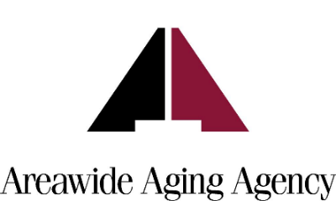

AGENDA
Areawide Aging Agency Board of Directors Meeting
Thursday, November 18, 2021  11:30 am
- Perimeter Center Drive, Suite 310, Oklahoma City, OK 73112

- Welcome and Introductions
- Minutes from October 20, 2021
- Finance Report
- Reports
  - Chair LaDonna Wilson
  - Executive Committee LaDonna Wilson
  - Finance Committee Kyle Tully
  - Fund Development Committee Jason Bailey
  - Nominating Committee Jessica McCormick
  - Strategic Committee Heath Wiederstein
  - CEO Report Blair Schoeb

- Update on procurement of an operator for a new meal site

- Announcements
  - The Annual Fish City Fundraiser is scheduled for December 7, for both lunch and dinner
  - Donations for the annual Christmas Cheer project are due by November 30.
  - The United Way Gala is scheduled for February 4.
- Adjournment
The meeting place is handicap accessible.

